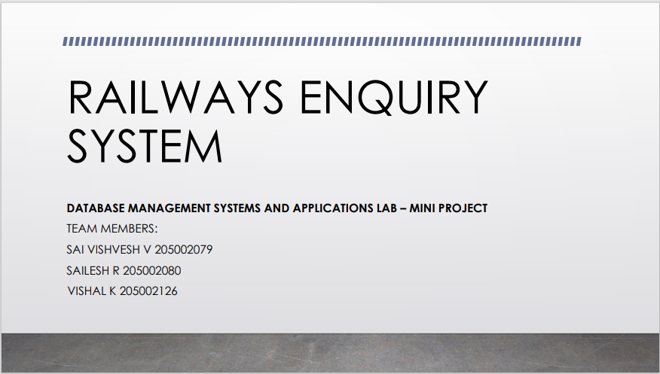

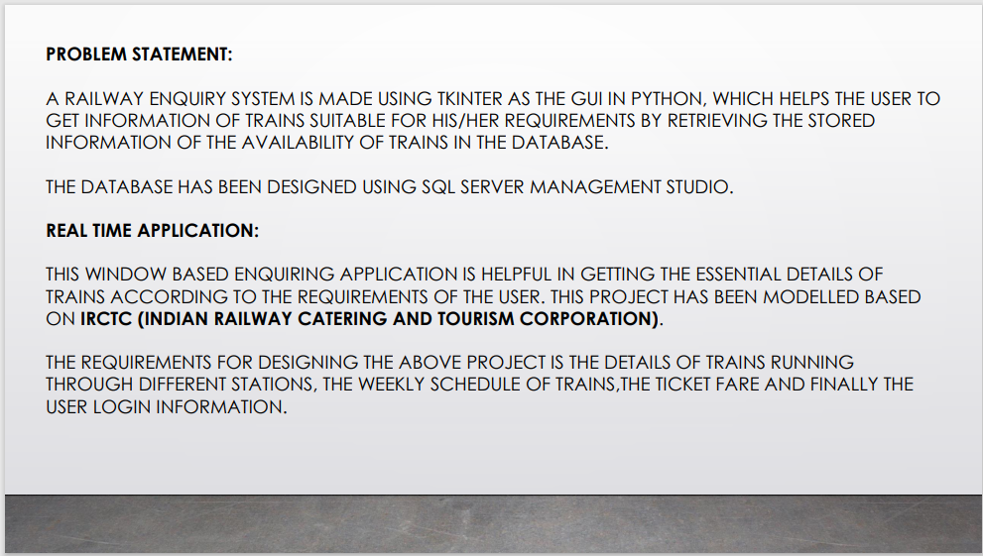

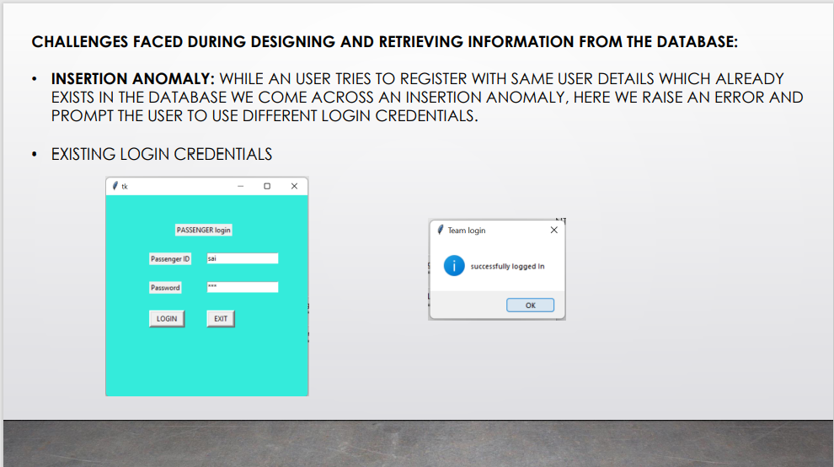

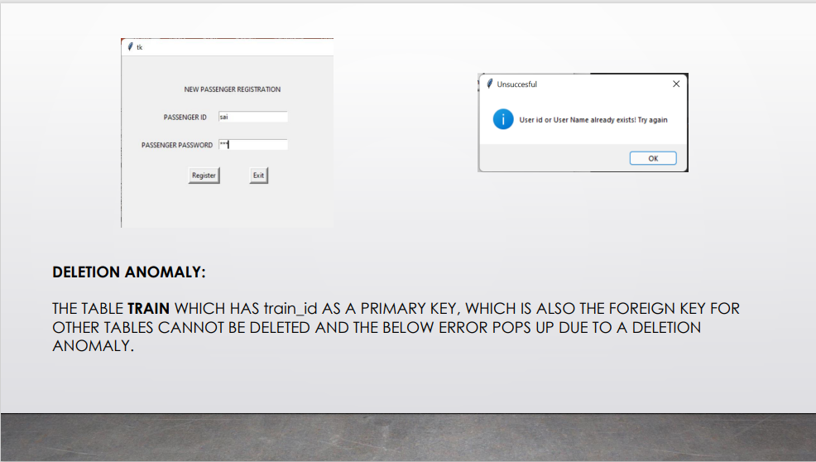

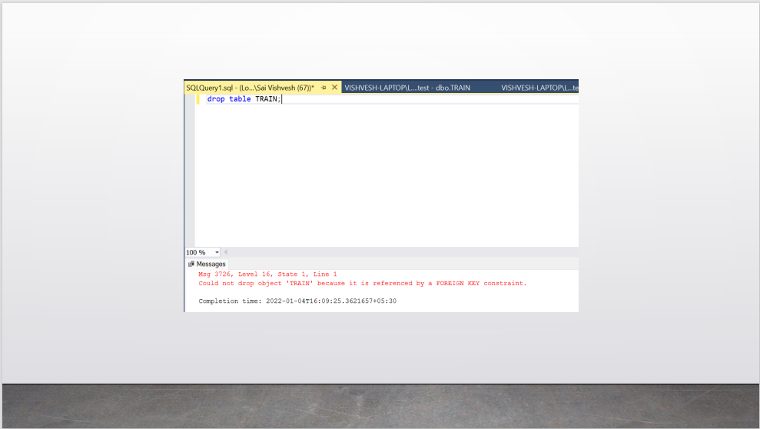

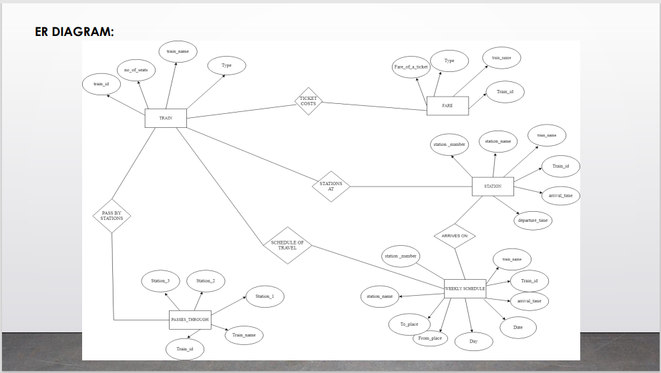

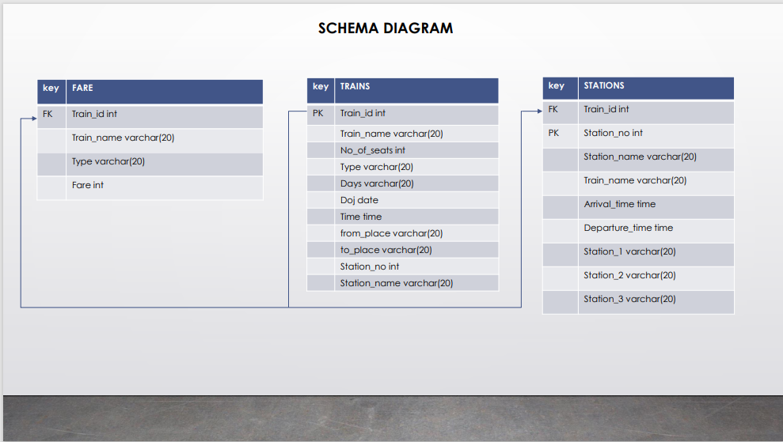

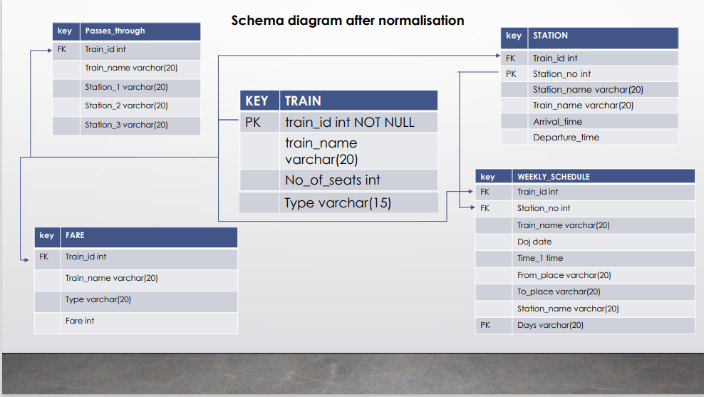

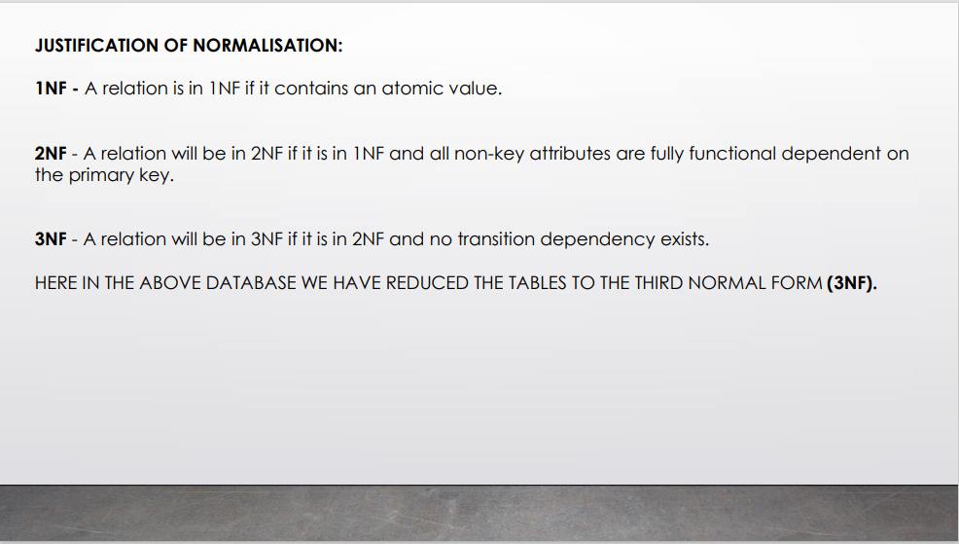

**CODE:**

**­­**import tkinter as tk  
from typing import List  
import pyodbc  
from tkinter import *  
from tkinter import ttk  
import tkinter.messagebox as messagebox  
  
conn = pyodbc.connect(  
 "Driver={SQL Server Native Client 11.0};"  
 "Server=(LocalDb)\MSSQLLocalDB;"  
 "Database=test;"  
 "Trusted_Connection=yes;")  
  
  
def inquire():  
 def last_exit():  
 messagebox.showinfo("Checked!!", "Thank you!!")  
  
 def search():  
 originn = origin_id.get()  
 destinationn = destination_id.get()  
 type = type_id.get()  
 date = date_id.get()  
 nooftickets = nooftickets_id.get()  
 *# origin_id.set("")  
 # destination_id.set("")* curr_search = conn.cursor()  
 s1 = "select train.train_id,Time from train,weekly_schedule where From_place='%s'and To_place='%s' and type='%s' and DateofJourney='%s' and train.train_id=weekly_schedule.train_id " % (  
 originn, destinationn, type, date)  
 curr_search.execute(s1)  
 count1 = 0  
 anss = 0  
 name_id = 0  
 timee = 0  
 depart_time = 0  
 for i in curr_search:  
 count1 += 1  
 anss = list(i)  
 name_id = anss[0]  
 timee = anss[1]  
 if count1 > 0:  
 root5.destroy()  
 root6 = Tk()  
 root6.geometry('200x300')  
 root6.title('Search results')  
 curr_last = conn.cursor()  
 curr_neww = conn.cursor()  
 s2 = "select total_fare,train_name,train.train_id from train,fare where train.train_id=fare.train_id and train.train_id='%d'" % (  
 name_id)  
 s3 = "select departure_time from station where train_id='%d'" % (name_id)  
 curr_last.execute(s2)  
  
 for i in curr_last:  
 checkk = list(i)  
 fare_no = checkk[0]  
 train_namee = checkk[1]  
 train_idd = checkk[2]  
 tot_fare = fare_no * nooftickets  
 last_head1 = Label(root6, text='Train Details').place(x=50, y=10)  
 last_head2 = Label(root6, text='Train Name-').place(x=10, y=40)  
 last_head3 = Label(root6, text='Train ID-').place(x=10, y=70)  
 last_head4 = Label(root6, text='Total Fare-').place(x=10, y=100)  
 last_head5 = Label(root6, text='Train Starting time-').place(x=10, y=130)  
 last_head6 = Label(root6, text=train_namee).place(x=100, y=40)  
 last_head7 = Label(root6, text=train_idd).place(x=100, y=70)  
 last_head8 = Label(root6, text=tot_fare).place(x=100, y=100)  
 last_head9 = Label(root6, text=timee).place(x=120, y=130)  
 Button(root6, text='Done', borderwidth=4, command=last_exit).place(x=100, y=190)  
 curr_last.close()  
 curr_neww.execute(s3)  
 for i in curr_neww:  
 checkk_1 = list(i)  
 depart_time = checkk_1[0]  
 last_head10 = Label(root6, text="Train departure time-").place(x=10, y=160)  
 last_head11 = Label(root6, text=depart_time).place(x=130, y=160)  
  
 else:  
 messagebox.showinfo("message,No trains available!!!")  
 root5.destroy()  
  
 def inquexit():  
 messagebox.showinfo("Team login", "THANK YOU!!!")  
 root5.destroy()  
  
 root5 = Tk()  
 root5.geometry('400x500')  
 root5.title('To search trains')  
 origin_id = StringVar(root5)  
 destination_id = StringVar(root5)  
 type_id = StringVar(root5)  
 date_id = StringVar(root5)  
 nooftickets_id = IntVar(root5)  
 headd1 = Label(root5, text='Enter detials').place(x=150, y=20)  
 headd = Label(root5, text='Enter origin').place(x=75, y=100)  
 entry_1 = Entry(root5, textvariable=origin_id).place(x=150, y=100)  
 headd2 = Label(root5, text='Enter destination').place(x=60, y=150)  
 entry_2 = Entry(root5, textvariable=destination_id).place(x=160, y=150)  
 headd_3 = Label(root5, text='Enter type').place(x=77, y=200)  
 entry_3 = Entry(root5, textvariable=type_id).place(x=150, y=200)  
 headd_4 = Label(root5, text='Enter date').place(x=77, y=250)  
 entry_4 = Entry(root5, textvariable=date_id).place(x=150, y=250)  
 search_bu = Button(root5, text='SEARCH', borderwidth=4, command=search).place(x=130, y=350)  
 headd_5 = Label(root5, text="Enter no of tickets").place(x=55, y=300)  
 entry_5 = Entry(root5, textvariable=nooftickets_id).place(x=160, y=300)  
 exit_bu = Button(root5, text='EXIT', borderwidth=4, command=inquexit).place(x=200, y=350)  
  
  
root = tk.Tk()  
root.geometry("400x300")  
root.title("Input User Details")  
  
  
def login():  
 root3 = Tk()  
 root3.geometry('400x250')  
  
 head3 = Label(root3, text="PASSENGER login").place(x=120, y=50)  
 head3_1 = Label(root3, text="Passenger ID").place(x=75, y=100)  
 head3_2 = Label(root3, text="Password").place(x=75, y=150)  
  
 def logininto():  
 passenger_id = p_id.get()  
 p_word = pass_word.get()  
 p_id.set("")  
 pass_word.set("")  
 cur3 = conn.cursor()  
 s1 = "select id from user_reg where id='%s' and r_password='%s'" % (passenger_id, p_word)  
 cur3.execute(s1)  
 c = 0  
 for i in cur3:  
 ans = list(i)  
 c += 1  
 if c == 1:  
 messagebox.showinfo("Team login", "successfully logged In")  
 root3.destroy()  
 root4 = Tk()  
 root4.geometry('400x200')  
  
 head4 = Label(root4, text="PASSENGER DETAIL").place(x=120, y=40)  
 head4_1 = Label(root4, text=ans).place(x=175, y=80)  
 fin_b = Button(root4, text='Search trains', borderwidth=4, command=inquire)  
 fin_b.place(x=145, y=120)  
 else:  
 messagebox.showinfo("Team login", "Invalid credentials!")  
 root3.destroy()  
  
 def loginexit():  
 messagebox.showinfo("Team login", "THANK YOU!!!")  
 root3.destroy()  
  
 p_id = StringVar(root3)  
 pass_word = StringVar(root3)  
  
 entry3_1 = Entry(root3, textvariable=p_id).place(x=175, y=100)  
 entry3_2 = Entry(root3, textvariable=pass_word, show='*').place(x=175, y=150)  
  
 b3_1 = Button(root3, text=" LOGIN ", borderwidth=4, command=logininto)  
 b3_1.place(x=75, y=200)  
  
 b3_2 = Button(root3, text=" EXIT ", borderwidth=4, command=loginexit)  
 b3_2.place(x=175, y=200)  
  
 root3.mainloop()  
  
  
def register():  
 def exitt():  
 messagebox.showinfo("THANK YOU FOR REGISTERING", "THANKS")  
 root2.destroy()  
  
 def passengerregister():  
  
 a = passenger_id.get()  
 b = password.get()  
 cur_1 = conn.cursor()  
 ins2 = "select * from user_reg where id= '%s' or r_password='%s'" % (a, b)  
 cur_1.execute(ins2)  
 count = 0  
 for i in cur_1:  
 count += 1  
 if count > 0:  
 messagebox.showinfo("Unsuccesfull", "Team id or Team Name already exists! Try again")  
 root2.destroy()  
 return  
 else:  
 cur1 = conn.cursor()  
 ins = "insert into user_reg(id,r_password) values('%s','%s')" % (a, b)  
 cur1.execute(ins)  
 conn.commit()  
 passenger_id.set("")  
 password.set("")  
  
 root2 = Tk()  
 root2.geometry('400x300')  
  
 passenger_id = StringVar(root2)  
 password = StringVar(root2)  
  
 head2 = Label(root2, text="NEW PASSENGER REGISTRATION").place(x=110, y=50)  
 head2_1 = Label(root2, text=" PASSENGER ID ").place(x=70, y=100)  
 head2_2 = Label(root2, text=" PASSENGER PASSWORD ").place(x=30, y=150)  
  
 entry2_1 = Entry(root2, textvariable=passenger_id).place(x=175, y=100)  
 entry2_2 = Entry(root2, textvariable=password, show='*').place(x=175, y=150)  
  
 b2_1 = Button(root2, text="Register", borderwidth=4, command=passengerregister)  
 b2_1.place(x=120, y=200)  
  
 b2_2 = Button(root2, text="Exit", borderwidth=4, command=exitt)  
 b2_2.place(x=230, y=200)  
  
 root2.mainloop()  
  
  
def main_exit():  
 messagebox.showinfo("Message", "Thank you")  
 root.destroy()  
  
  
head1 = Label(root, text='For Passenger registration')  
head1.place(x=20, y=50)  
  
b1_1 = Button(root, text="Passenger regsitration", borderwidth=4, command=register)  
b1_1.place(x=165, y=45)  
  
headd1 = Label(root, text='For passenger Login')  
headd1.place(x=40, y=120)  
  
b1_2 = Button(root, text="Passenger Login", borderwidth=4, command=login)  
b1_2.place(x=175, y=120)  
  
b1_3 = Button(root, text="Exit", borderwidth=4, command=main_exit).place(x=175, y=200)  
  
root.mainloop()

**OUTPUT SCREENSHOTS:**

**TABLES:**

**Train:**

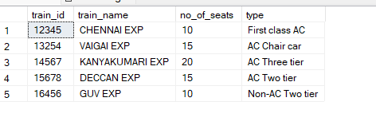

**Station:**

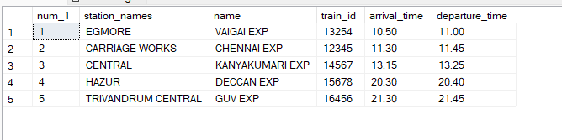

**Passes Through:**

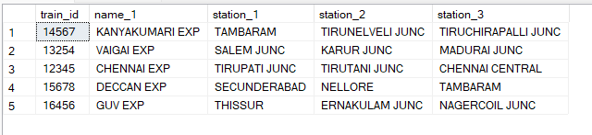

**Weekly Schedule:**

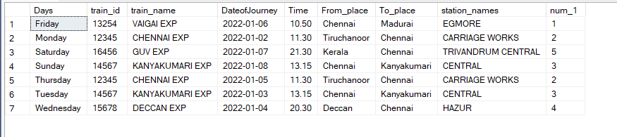

**Fare:**

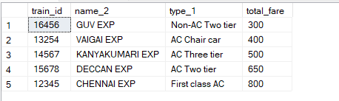

**WINDOWS:**

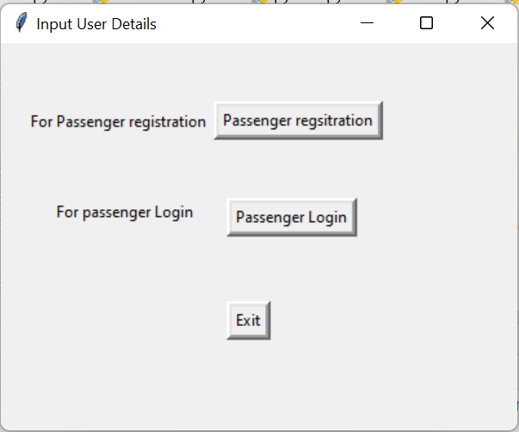

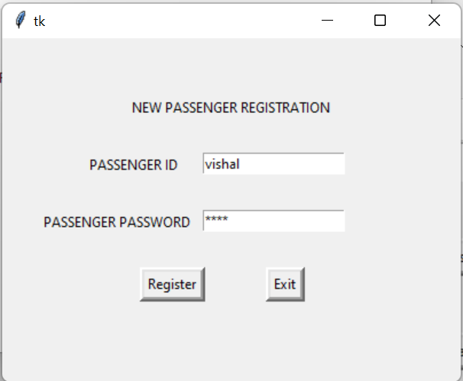

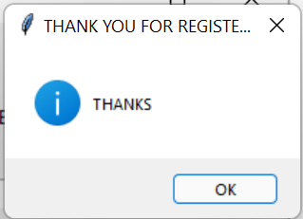

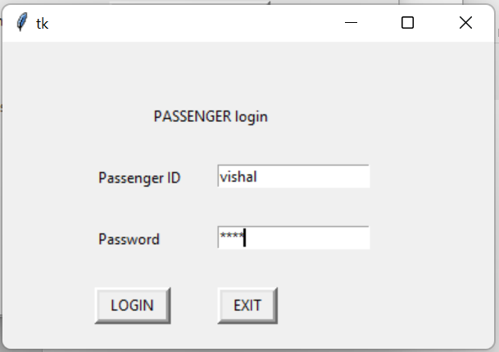

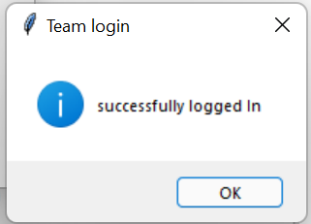

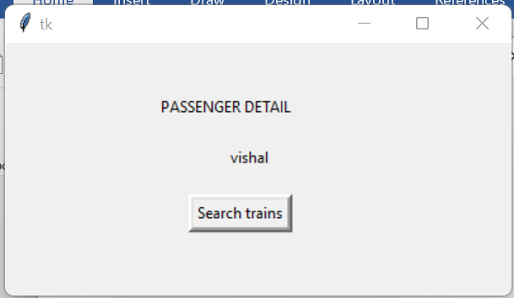

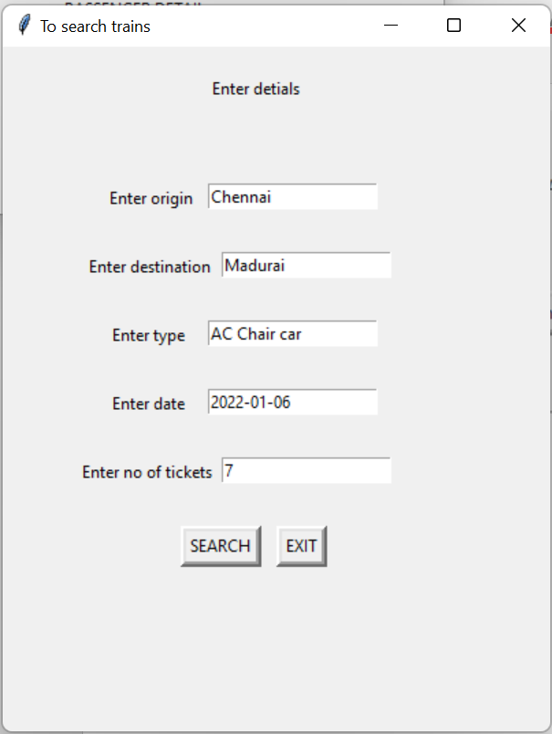

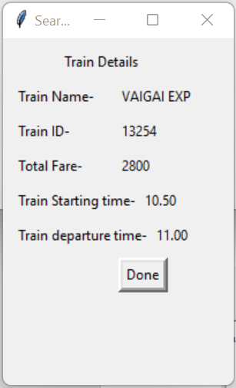

**APPENDIX:**

The [tkinter](https://docs.python.org/3/library/tkinter.html" \l "module-tkinter" \o "tkinter: Interface to Tcl/Tk for graphical user interfaces) package (“Tk interface”) is the standard Python interface to the Tcl/Tk GUI toolkit. Both Tk and [tkinter](https://docs.python.org/3/library/tkinter.html" \l "module-tkinter" \o "tkinter: Interface to Tcl/Tk for graphical user interfaces) are available on most Unix platforms, including macOS, as well as on Windows systems.

Running python -m tkinter from the command line should open a window demonstrating a simple Tk interface, letting you know that [tkinter](https://docs.python.org/3/library/tkinter.html" \l "module-tkinter" \o "tkinter: Interface to Tcl/Tk for graphical user interfaces) is properly installed on your system, and also showing what version of Tcl/Tk is installed, so you can read the Tcl/Tk documentation specific to that version.

Tkinter supports a range of Tcl/Tk versions, built either with or without thread support. The official Python binary release bundles Tcl/Tk 8.6 threaded. See the source code for the _tkinter module for more information about supported versions.

Tkinter is not a thin wrapper, but adds a fair amount of its own logic to make the experience more pythonic. This documentation will concentrate on these additions and changes, and refer to the official Tcl/Tk documentation for details that are unchanged.

Button Insertion:

w = Button ( master, option=value, ... )

Entry:

w = Entry( master, option, ... )

Label:

w = Label ( master, option, ... )

MessageBox:

tkMessageBox.FunctionName(title, message [, options])